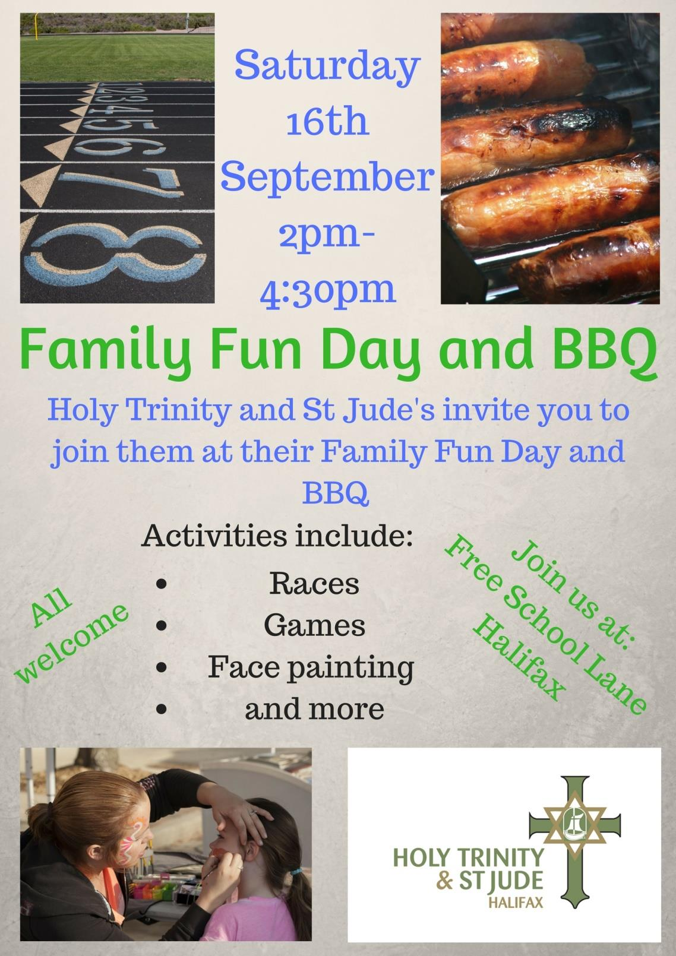 

**Where can you contact us?**

For up-to date information, you can find us on Facebook, join our Whatsapp group or contact:

Revd Richard: 01422 352446 or email [richard.frith@holytrinitystjudes.org.uk](mailto:richard.frith@holytrinitystjudes.org.uk)

Revd Michelle: 01422 362220 or email michelle.petch@ holytrinitystjudes.org.uk

**Hello**

Welcome back!

Autumn days when the grass is jewelled, and the silk inside the chestnut shell!

It’s great to be back together for Families@Four for the autumn term. We’ve got some really exciting things coming up at church this term:

* a new theme, sharing some of the best-loved stories from the Old Testament. On some weeks, Revd Michelle is going to be helping us to think about these using ‘Godly Play’, a creative and imaginative way of storytelling that children will love.
* a fabulous Family Fun Day and Barbecue on 16thth September
* a colourful Rainbow Harvest Festival in October
* and at the end of it all, Christmas, with all its wonder – Christingle, the Crib Service, and even this year a Christmas Party for our children!

Everyone is welcome, always and to everything. Hope to see you soon.

God bless, Revd Richard

God bless, Revd Richard

**Issue 3 - 2017 Q4**

**Autumn Newsletter**

**When do we meet?**

We meet 4-5pm at St Jude’s Church every Sunday with the exception of the main school holidays. This term runs from Sunday September 10th to Sunday December 3rd. We will then start back on Sunday 7th January 2018.

**Dates to remember**

Sun 10th Sept 4pm First Families@Four service of the new term

Sat 16th Sept 2-4.30 pm FAMILY FUN DAY AND BBQ at church

Sun 1st Oct 10am Rainbow Harvest Festival Service (uniformed organisations)

Sun 5th Nov 10am All Saints Sunday Family Service (uniformed organisations)

Sun 10th Dec 4pm Christingle Service

Sat 16th Dec HOLY TRINITY & ST JUDE'S CHILDREN'S CHRISTMAS PARTY

Sun 17th Dec No Families@Four

Sun 24th Dec 4pm Christmas Crib Service (Christmas Eve)

Mon 25th Dec 10am Christmas Family Communion (Christmas Day)

Sun 31st Dec No Families@Four (New Year’s Eve)

Sun 7th January 4pm First Families@Four of the new term (Epiphany)

**Other news**

Everyone who attends Families@Four is always welcome to join the monthly all-age morning service, usually on the first Sunday of the month. You are especially invited to the ‘Rainbow Harvest’ Family Service on Sunday 1st October at 10am. You are encouraged to take part on that day by wearing clothes which are a colour of the rainbow and bringing harvest gifts, especially tinned and dried foods, that are a rainbow colour too. All the different church children’s groups have been invited to take part. Maybe we could make something to show on that day? Please come along and help to make the church a rainbow of colours, as we join together with the whole church family to celebrate the colour and variety of God’s creation.

Tiddlers takes place every Thursday 9-11am in the Church Hall for children 0-4 and their parents/carers.

**What are our themes?**

Our theme for the Autumn term, until the beginning of Advent, will be Old Testament stories. We will begin by looking at the Bible as a collection of many different books and then explore some of the stories and characters in the Old Testament books. The Old Testament is the part of the Bible that was written many years before Jesus was born. This will include some ‘Godly Play’ stories. Come along and find out more if you haven’t experienced these before!